- Copyright for test papers and marking guides remains with West Australian Test Papers.
- The papers may only be reproduced within the purchasing school according to the advertised conditions of sale.
- Test papers must be withdrawn after use and stored securely in the school until Wednesday 14th October 2015.



HUMAN BIOLOGICAL SCIENCE
STAGE 3

2015

MARKING GUIDE

Section One: Multiple-choice 30% (30 marks)

Question | Answer
1 | B
2 | D
3 | A
4 | D
5 | A
6 | D
7 | B
8 | C
9 | B
10 | D
11 | C
12 | A
13 | D
14 | B
15 | B
16 | D
17 | D
18 | A
19 | C
20 | B
21 | C
22 | C
23 | D
24 | D
25 | A
26 | D
27 | B
28 | C
29 | A
30 | B

Section Two: Short Answer 50% (100 marks)
This section has eight (8) questions. Answer all questions. Write your answers in the spaces provided.
Suggested working time: 90 minutes.

Question 31 (12 marks)

- Identify structures C, D and E indicated by labels on the diagram.
(3 marks)
C synovial membrane

D articular cartilage

E synovial fluid / synovial cavity

- In the table below, summarise the features of two other types of joints (4 marks)

Type of Joint | Description | Example
Immoveable | No movement possible as bones fixed / tethered by fibrous connective tissue | Sutures of the skull / teeth against the jaw
Cartilaginous | Small degree of movement possible due to presence of cartilage | Symphysis pubis / intervertebral discs/ joints between ribs and sternum

- Osteoarthritis is a disease usually associated with ageing that affects the skeletal system.

- State the part of the joint that, when damaged, leads to osteoarthritis. (1 mark)

Articular Cartilage / D

- Name two other symptoms that a person would have if the area in part (b)(i) was damaged. (2 marks)

- Restricted movement / joint stiffness
- Pain during joint movement
- Inflammation / swelling of joint structures
    - Rubbing, cracking or grating sound when moving joint

- State two medical technologies currently available for the treatment of this disease. (2 marks)
Any 2

- Joint replacement surgery
- Physiotherapy
- TENS
- tissue engineering
- pain medication
- surgery to re-align bones
- anti-inflammatories
- thermotherapy

Question 32 (13 marks)

- Complete the table below by placing the tools A, B, C and D in the correct evolutionary sequence, from oldest to most recent. Include the hominin species it is associated with.
(4 marks)

Letter –  A, B, C or D | Name of Tool Culture | Used by
C | Oldest Oldowan | Homo habilis
A | Acheulian | Homo erectus
B | Mousterian | Homo neanderthalensis
D | Youngest Upper Paleolithic / Solutrean | Homo sapiens

Each row must be correct for 1 mark each

- Hominin tool culture has distinctly changed over time.

List one trend relating to (2 marks)

- manufacture – increased workmanship / number of flakes removed / finer detail / more complex designs / increase in variety of materials used

- use – tools became specialised in function / wider variety of tools meant many more uses possible / relevant examples of use acceptable here as long as it shows generalised → specialised

- It is believed that tool use became possible with the transition to bipedalism.

Explain an adaptation for each biological structure that could have led to the evolution of bipedalism. (4 marks)

(Any adaptation with matching explanation for each structure)

Structure | Adaptation | How this assists bipedal movement
Foot | Large heel bone | Weight bearing
Foot | Longitudinal and transverse arches | Distribute weight when standing / shock absorption when walking
Foot | Non-opposable big toe / robust / aligned with other toes | Used to propel individual when walking (‘push off’ with big toe)
Hip Joint | Femurs positioned wide apart | Facilitates carrying angle so weight transmitted directly under centre of body
Hip Joint | Large femoral head/ COG and shape of pelvis

- Hominin skulls exhibit many changes though time.

State three evolutionary trends evident in hominin skulls. (3 marks)

Any three:
- increased cranial capacity / rounder and higher cranium
- size of brow ridges reduced / forehead develops
- reduced prognathism / flatter face
- appearance of a chin
- reduction in zygomatic arches
- dental arcade moves from ‘deep U’ shape to become parabolic as face flattens
- reduction in relative jaw size / size of teeth decreases

Question 33 (13 marks)
Amelia is lying on the couch watching TV when she smells her toast burning. She quickly jumps up but then suddenly feels light-headed and dizzy. Her friend, Jonah, explains to her that she feels this way because her blood pressure has dropped and it will be short-lived due to a stimulus-response feedback loop.

- List the components of a stimulus-response feedback loop in the correct sequence.
(1 mark)
Stimulus – receptor – modulator – effector – response – negative / positive feedback

- Explain three responses by Amelia’s body that prevent her blood pressure from remaining low. (3 marks)

Any three
- Increased sympathetic stimulation / adrenaline / noradrenaline
- Decreased parasympathetic stimulation
- Causes vasoconstriction of blood vessels
- Increases heart rate / force / stroke volume / cardiac output
- Increases blood pressure (must be linked to response above)

- Which part of the brain is responsible for coordinating the responses in part (b)? (1 mark)

Medulla oblongata (vasomotor and cardiac centres)/ Cardiovascular Regulating Centre

- Provide two other diseases or environmental circumstances that could lead to hypotension (low blood pressure). (2 marks)

Any two

- Heroin use
- Injury resulting in blood loss
- Emotions of stress / fear / pain
- Dehydration
- Blood donation
- Pregnancy
- Parkinson’s or any other relevant examples

- Control of blood pressure relies on both the nervous and endocrine systems.

Complete the table below, outlining the ways that these modes of transmission differ.
(6 marks)
 | Endocrine | Nervous
Time for reaction to occur | Slower / seconds to weeks | rapid / milliseconds
Duration | Longer / persists after stimulus removed | Brief / only while stimulus remains
Specificity | More generalised / can effect more than one organ | Highly specific / usually only one effector
Question 34 (15 marks)

- Propose a hypothesis for this investigation. (1 mark)

Hypothesis must state how independent variable affects dependent variable (increase / decrease / no effect)
e.g. Petrilnez increases the distance a muscular dystrophy sufferer can travel.

- State two variables that were controlled in the experiment. (2 marks)

Any two
- Dosage of drug same for each patient / 30mg/kg
- Number of times Petrilniz and placebo administered
- Method of administration (injection)
- All patients suffering from Duchenne muscular dystrophy
- Time subjects performed walking test (5 minutes)

- Graph the results on the grid provided below. (5 marks)
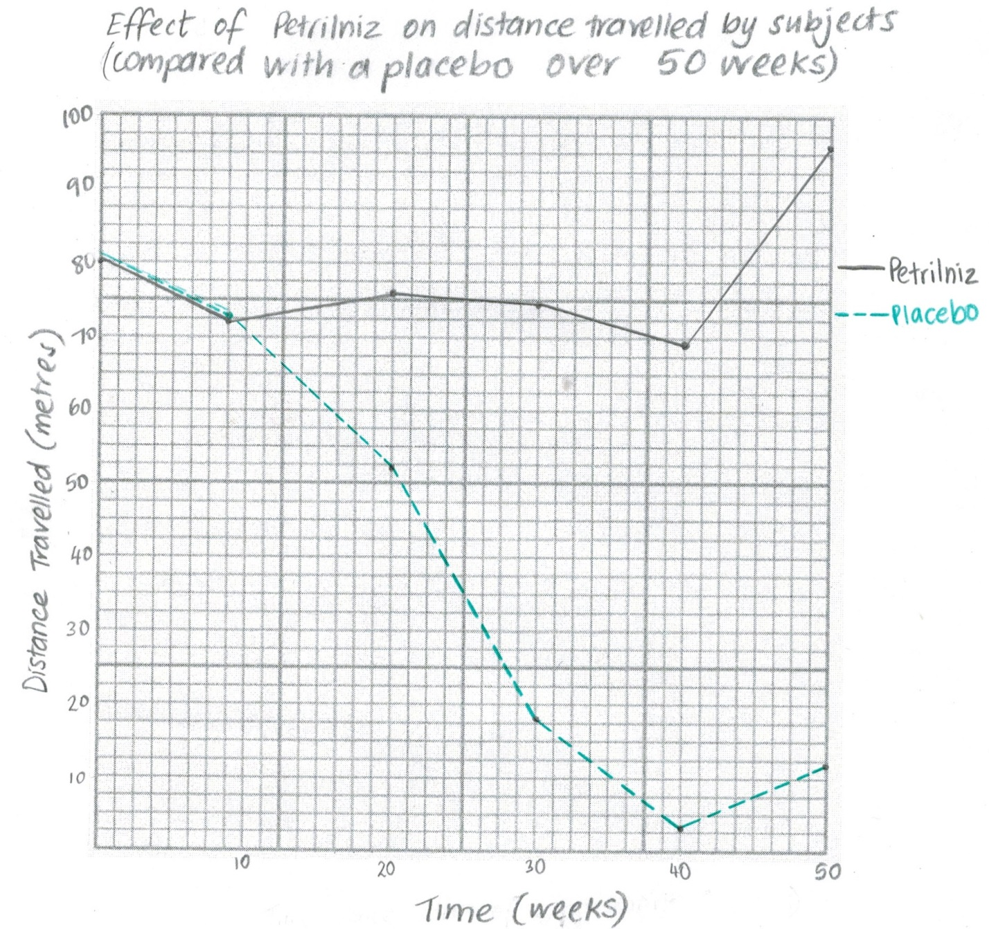
Bar graph – maximum 3 marks
- Points plotted correctly and joined to form a line
- Title must include independent and dependent variable
- X and Y axis labelled correctly, including units
- Axes constructed using appropriate scale (at least half the grid)
- Each line labelled / shown in legend
- In 1986, researchers identified a gene that, when mutated, caused Duchenne muscular dystrophy. Couples with a family history of this disease may wish to undergo DNA profiling to determine their risks of conceiving a child with this disease.

- Explain how the process of electrophoresis is able to create a DNA profile for this couple. (4 marks)

Any four
- DNA pieces placed on gel bed at negative end
- Electric current passed through gel bed
- DNA is negatively charged so moves towards positive electrodes at far end of gel bed
- Small DNA pieces move faster than larger ones
- DNA separates to form band pattern representative of different sized DNA (DNA profile / fingerprint)

- Once a DNA profile is created, the DNA is denatured and exposed to a genetic probe. Explain what a genetic probe is and how it is used to identify whether the couple carry the mutation for Duchenne muscular dystrophy. (3 marks)

- Fragment of DNA that is complementary to mutated gene for Duchenne (must have this for 1 mark)
- That is labelled with radioactive isotopes / fluorescent marker
- Binds to mutated gene
(or vice versa if probe designed for normal gene)

Question 35 (12 marks)

- According to the cladogram, which group of primates was the first to diverge in evolutionary time? (1 mark)

Lemurs and lorises

- Complete the table below, describing three Primate evolutionary trends. (3 marks)

Trend | Significance
Relative size of the cerebral cortex | Increase in the relative size of cerebral cortex
Olfactory / optical shift | Increased visual ability while sense of smell decreases
Parental care | Increased length of time being cared for / increased time dependent on parents

- Scientists trying to establish the evolutionary relationship between primates decided to complete a comparative study using nuclear DNA.

- Describe how this would be conducted. (2 marks)

Any 2
- Work out the DNA sequence for each primate species in question
- Compare the DNA sequences for each species
- Comparison of viral sequences (ERVs) / explanation of hybridisation process

- Explain how it could show evolutionary relationships between primates. (1 mark)

More differences in DNA sequences means longer time since they diverged from a common ancestor / vice versa

- Palaeontologists are yet to find a common ancestor for chimpanzees and humans in the fossil record. It is thought to have lived between 5 and 7 million years ago.

- Suggest three reasons why such a fossil has been hard to find. (3 marks)

Any 3
- Conditions for fossilisation has not been met (no fossil)
- Inaccessible location / buried too deep in the ground
- Destroyed by human / geological activity (eg folding, volcanic)
- Unable to date fossil as it does not meet limitations
- Fossil too fragmented
- Scientists disagree with interpretation of fossils

- A scientist who is completing excavations in Eastern Africa unearths a fossil he believes is the ‘missing link’ between chimpanzees and humans. If this is true, explain why C-14 dating would be of little use in this scenario. (2 marks)

Fossil is older than 60 000 years / too old
Not enough C-14 remaining in fossil to provide accurate date

Question 36 (12 marks)

- Identify the structures labelled A and B. (2 marks)

A: sarcolemma
B: myofibril

- Units along structure A are called sarcomeres. Draw a labelled uncontracted sarcomere and its associated components in the box below. (4 marks)

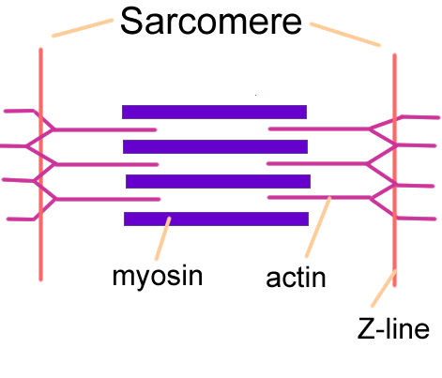
- Actin drawn thin and labelled correctly
- Myosin drawn thick and labelled correctly
- Z lines shown as the boundary of sarcomere (label of Z lines not required)
- Incomplete overlap of actin and myosin shown
- H-zone contains just thick filament

- The nervous system controls the contraction of skeletal muscle. Explain the role of the brain in achieving this. (2 marks)

Cerebral cortex/primary motor area is responsible for planning muscle activity / sending impulses to muscles via motor neurons
Cerebellum coordinates fine movements of muscles.

- Describe the effect that nervous stimulation has on the structure illustrated in part (b).
(4 marks)
Any four:
- Release of calcium ions from sarcoplasmic reticulum bind to actin
- Myosin heads / crossbridges attach to actin
- Myosin pulls on actin
- Allowing filaments to slide past one another
- decreasing distance between Z lines
- and shortening the sarcomere

Question 37 (12 marks)
An investigation was done on 40 pairs of identical twins to determine the effect of epigenetics. Researchers noted that twins that were infants had indistinguishable epigenomes, while those who were elderly had quite different epigenomes.

- State what epigenetics refers to. (1 mark)

Changes in gene expression / physical traits as a result of environmental conditions / not caused by changes to underlying DNA sequence/ additions of chemicals or proteins to the DNA without altering the base sequence

- Explain how the epigenome can be changed by

- Histone modification (2 marks)
- Acetyl group added to histone
- Allowing genes to be expressed / accessed for transcription / switched on
OR
- Amino acids in histone modified
- Causing a change in its shape that will be heritable in future DNA molecules/ changes shape enhancing gene expression

- DNA methylation (2 marks)
- Methyl groups bind to DNA (at CpG sites)
- Preventing expression of genes/ switched off

- Propose a reason for the different observations collected from the young and elderly sets of twins. (1 mark)

Elderly twins have been exposed to more differences in their environment

There are times when the environment alters gene expression producing a result that is relatively short-lived and not heritable. Skin pigmentation is one such example.

- Explain how the environment plays a role in altering skin pigmentation. (3 marks)

Exposure to ultraviolet light stimulates melanocytes
Melanocytes produce melanin (increases the pigment of skin)
More ultraviolet light = darker skin / vice versa

- Skin colour is primarily controlled by polygenes. Explain how this mode of inheritance is responsible for the range of skin colour phenotypes that can be observed. (3 marks)

Multiple pairs of genes interact / not just one pair of alleles
Each allele contributes equally to phenotype/codominance in alleles
Each allele acts in an additive way

Question 38 (11 marks)

- Describe how the adrenaline would act on her body to relieve breathing difficulties. (1 mark)

Dilation of bronchi/bronchioles to allow increased flow of air.

- Identify a situation in which the body would naturally release its own supply of adrenaline and state which endocrine gland it would be released from. (2 marks)

Exercise / stress / fear / any relevant scenario
Adrenal gland / adrenal medulla

- Adrenaline is released as a result of stimulation by the sympathetic division of the nervous system.
In the table below, describe the effects the sympathetic division has on other body structures. (3 marks)
Structure | Effect
Heart | increase strength of contraction /  increase in heart rate
Blood vessels of skeletal muscle | (vaso)dilation
Intestines | decreased movement /  activity

- Adrenaline is classified as an amine hormone. Contrast the action of amine hormones with steroid hormones. (2 marks)

Amine bind to receptor on cell membrane, steroid bind to receptor inside cell
Amine cause changes in enzyme activity/cellular activities, steroid change gene expression

- Explain how receptor proteins interact with hormones. (3 marks)

Any three:
- Receptor proteins are specific to one hormone
- Where hormone shape matches receptor site / explanation of lock and key principle
- Number of receptor proteins determines rate of cell activity/can become saturated (despite amount of hormone)
- Receptor proteins on surface of cell membranes activate secondary messenger when hormone binds
- Receptor proteins in cytoplasm able to enter nucleus when hormone binds.
Section Three: Extended Answer 20% (40 marks)
Question 39

- Neurotoxins are chemicals contained in the snake’s venom that mimic the shape of the acetylcholine molecule. Describe how nerve impulses are usually propagated at the synapse and explain how the neurotoxin interfered with this process in Tim’s situation. (11 marks)
Description | Marks
Usual synapse  Any 9 of the following: | 1-9
- impulse passes between two neurons at a synapse | 1-9
- Pre-synaptic neuron has (enlarged tips called) synaptic knob | 1-9
- Synaptic knob houses vesicles containing neurotransmitters / acetylcholine | 1-9
- Synaptic knob fits into depression on post-synaptic neuron | 1-9
- There is a gap between neurons called synaptic cleft | 1-9
- When nerve impulses travel down axon to synaptic knob, | 1-9
- it triggers vesicles to fuse with presynaptic membrane | 1-9
- This releases neurotransmitters into the synaptic cleft/ by exocytosis | 1-9
- Neurotransmitter diffuses to the dendrite of post-synaptic neuron | 1-9
- Neurotransmitter binds to specific protein receptor on dendrite | 1-9
- Triggering a nerve impulse to be generated in this neuron / causing depolarisation | 1-9
Effect of neurotoxin  Any 2 of the following: | 1-2
- Neurotoxin blocks receptor on dendrite preventing binding of acetylcholine | 1-2
- So no nerve impulse able to be generated/transmitted in post-synaptic neuron. | 1-2
- No muscle contraction stimulated = paralysis / difficulty controlling muscles | 1-2
 | Total 11

- At the hospital Tim was given an injection of anti-venom that contained tiger snake venom antibodies. Explain how antibodies are produced in the body and their role in providing a defence. (9 marks)
Description | Marks
Production of antibodies  Any 4 of the following: | 1-4
- Antigen identified by/activated specific B cell / lymphocyte | 1-4
- B cell is sensitised and enlarged | 1-4
- Cloning behaviour / makes multiple copies of itself | 1-4
- Most clones become plasma cells | 1-4
- Plasma cells make antibodies | 1-4
Role  Any 5 of the following: | 1-5
- Antibodies travel throughout the body | 1-5
- Locate specific antigen | 1-5
- Attach to antigen / forms antigen-antibody complex | 1-5
- Cause agglutination / clumping of antigen | 1-5
- Make antigen insoluble  - Bind to virus preventing it entering host cells  - Inhibit reactions with other cells which can lead to cell lysis | 1-5
- Enhance phagocytosis / increase macrophage activity | 1-5
 | Total 9

Question 40

- Regulation of blood glucose is important to ensure cells are able to access a ready supply of energy when required.

Describe the homeostatic mechanism that returns blood sugar to optimal levels when a period of fasting has occurred. (8 marks)
Description | Marks
Any 8 of the following: | 1-8
- Low blood glucose levels | 1-8
- Detected by alpha cells (in the Islets of Langerhans) of the pancreas | 1-8
- Release glucagon | 1-8
- Glucagon targets the liver | 1-8
- Causes glycogen to break down to glucose / glycogenolysis | 1-8
- Glucagon also causes gluconeogenesis / fats and amino acids used to produce glucose | 1-8
- Adrenal cortex releases cortisol for glycogenolysis | 1-8
- Cortisol also triggers removal of amino acids from muscles cells, sending them to liver to be converted to glucose/ gluconeogenesis | 1-8
- Adrenal medulla releases adrenaline/noradrenaline for glycogenolysis / breakdown of glycogen to glucose | 1-8
- Increased blood sugar levels | 1-8
 | Total 8

- It is estimated that over 1 million Australians suffer from diabetes. About 120,000 people are diagnosed with type 1 diabetes and 956,000 with type 2.

Compare and contrast the types of diabetes individuals may suffer from and explain the management options available for each group.
(12 marks)
Description |  | Marks
Type 1 | Type 2 | 1-8 (1 mark per box)
- Elevated blood glucose | - Elevated blood glucose | 1-8 (1 mark per box)
- Insulin-producing cells / beta cells of pancreas destroyed (by autoimmune reaction) | - Beta cells / Pancreas makes some insulin | 1-8 (1 mark per box)
- So inadequate insulin circulating in the body / insulin cannot be produced | - But body cells do not respond / resistant to effect of insulin | 1-8 (1 mark per box)
- Usually starts from young age | - Usually in adults over 45 / middle age / obese people / sedentary lifestyle choice / high blood pressure | 1-8 (1 mark per box)
Management
Any 2 points from each box
- Insulin must be administered  - Through regular injections  - Or programmable pump (continuous supply) | - Diet low in fat / sugar / salt  - Regular exercise  - Maintaining a healthy weight  - Medication if other measures unsuccessful | 1-4
 |  | Total 12

Question 41

The HEXA gene codes for an enzyme that breaks down lipids found within cells, mostly in the central nervous system. If both alleles for this gene are mutated, the individual will suffer from a fatal disease called Tay-Sachs.

- In Australia, the frequency of the mutated allele is very low, about 1 in 300. In the Ashkenazi Jew population, however, the frequency is about 1 in 26.
Explain two evolutionary mechanisms that scientists reason could be the cause for such different gene pools.
(7 marks)
Description | Marks
Random Genetic Drift | 1-7
- Small population | 1-7
- Increase in frequency due to chance | 1-7
- Likely as Ashkenazi Jews are (a small and) reproductively isolated population | 1-7
Natural Selection | 1-7
- Carrier / heterozygote survival advantage | 1-7
- Increased resistance to tuberculosis | 1-7
- Survivors more likely reproduce and pass allele to offspring | 1-7
- High selection pressure for allele as Jews subject to higher tuberculosis risk (in overcrowded ghettos) | 1-7
 | Total 7

- Researchers are hoping to start human clinical trials for Tay-Sachs disease using gene therapy. They hope to achieve this by using modified viruses that are infused into cerebrospinal fluid.
Describe the process of how the viruses would be genetically engineered and then how it could lead to a treatment for Tay-Sachs. (13 marks)
Description | Marks
- The normal (HEXA) gene is removed | 1-11
- by cutting it at a recognition site | 1-11
- With a restriction enzyme | 1-11
- Which makes a staggered cut made on either side of gene | 1-11
- Creating sticky ends from (overhanging) unpaired nucleotides | 1-11
- DNA / genetic material removed from virus | 1-11
- Viral DNA cut with same restriction enzyme | 1-11
- To create sticky ends that are complementary to gene | 1-11
- DNA ligase is an enzyme | 1-11
- That joins sticky ends of gene and viral DNA | 1-11
- This amalgamation is called recombinant DNA | 1-11
- Which is inserted back into virus | 1-11
- Virus is now termed a vector | 1-11
- Once inserted in the body, the virus would insert correct gene into body cells / replace faulty gene | 1-2
- Gene could then function to produce the correct protein / enzyme | 1-2
 | Total 13

